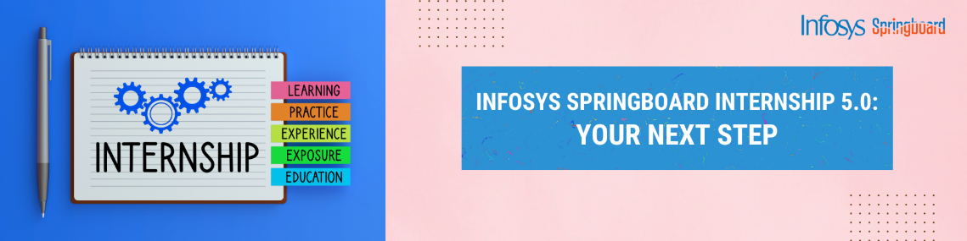

Title: Customer Segmentation Analysis

using Power Bi

DAX Queries used :

1) New Customers = CALCULATE(DISTINCTCOUNT(Orders[Customer ID]),FILTER( Orders,Orders[First Purchase Year] = SELECTEDVALUE(DimDate[Year])))

2) Sales LastYear = CALCULATE([TotalSales],SAMEPERIODLASTYEAR('DimDate'[Date]))

3) YoY Growth = DIVIDE(SUM(Orders[Sales]) - [Sales LastYear], [Sales LastYear], 0)

4) AvgOrderValuePerCustomer = DIVIDE(SUM(Orders[Sales]),DISTINCTCOUNT(Orders[Customer ID]))

5) AvgOrderValuePerOrder = DIVIDE(SUM(Orders[Sales]),DISTINCTCOUNT(Orders[Order ID]))

6) AvgOrderValue = DIVIDE(SUM(Orders[Sales]),DISTINCTCOUNT(Orders[Order ID]))

7) First Purchase Year = YEAR(CALCULATE( MIN(Orders[Order Date]), ALLEXCEPT(Orders, Orders[Customer ID])))

8) PreviousYear Sales = CALCULATE(SUM(Orders[Sales]),SAMEPERIODLASTYEAR(Orders[Order Date]))

9) Recency = DATEDIFF(MAX(Orders[Order Date]),TODAY(),DAY)

10) Monetary Value = CALCULATE(SUM(Orders[Sales]),ALLEXCEPT(Orders,Orders[Customer ID]))

11) PurchaseFrequency = DIVIDE(DISTINCTCOUNT(Orders[Order ID]),DISTINCTCOUNT(Orders[Customer ID]),0)

12) Total Customers = DISTINCTCOUNT('Orders'[Customer ID])

13) TotalSales = SUM(Orders[Sales])

14) DistinctCustomers = DISTINCTCOUNT(Orders[Customer ID])  
15) CustomerLifeTime = DATEDIFF(MIN(Orders[Order Date]),MAX(Orders[Order Date]),YEAR)

16) CustomerLifeTimeValue = [PurchaseFrequency]\*[AvgOrderValue]\*[CustomerLifeTime]

Some other measures:

1) qty MTD = TOTALMTD(SUM(Orders[Quantity]),DimDate[Date].[Date])

2) qty QTD = TOTALQTD(SUM(Orders[Quantity]),DimDate[Date].[Date])

3) qty YTD = TOTALYTD(SUM(Orders[Quantity]),DimDate[Date].[Date])

4)SalesBefore5Days = CALCULATE(SUM(Orders[Sales]),DATEADD(DimDate[Date].[Date], 5,DAY))

5) TotalSalesAfter5daysFromToday = CALCULATE(SUM(Orders[Sales]),DATESINPERIOD(DimDate[Date].[Date],

LASTDATE(DimDate[ Date].[Date]),5,DAY))